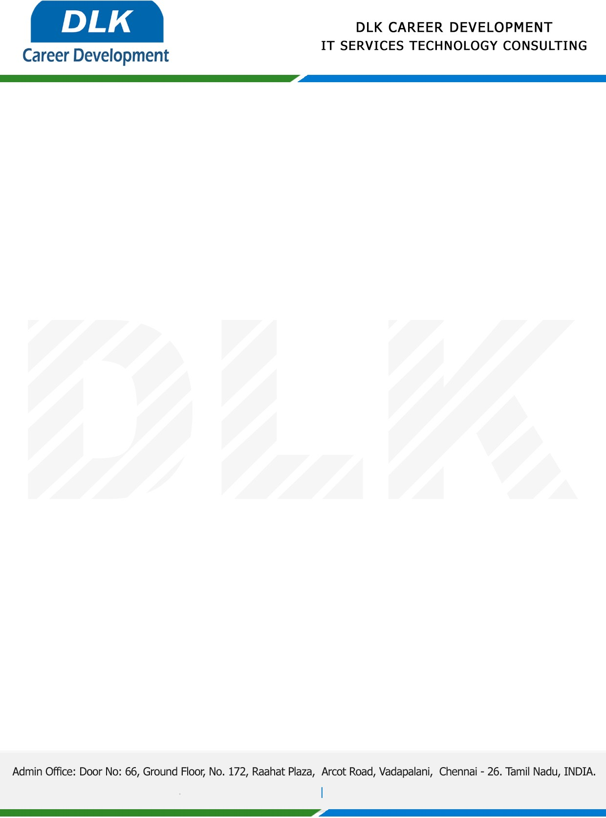

**Date: 14/February/ 2023**

**SUB: INTERNSHIP COMPLETION CERTIFICATE**

This is to certify that **MR PREM KUMAR G (REG NO: RA2031241040046)** of **BCA (Computer Application)** third year student at **SRM Institute of Science and Technology, Chennai** has Successfully Completed the Internship Work under the domain of **“Python with Artificial Intelligence  “** in our organization during the Period **(21st January 2023** to **10th February 2023).**

We appreciate your interest in **DLK CAREER DEVELOPMENT**

**“Best Wishes for Your Future Endeavors “**

For **DLK CAREER DEVELOPMENT**

**HR Manager**

**VELMURUGAN J**